Java Exception propagation

|  |
| --- |
| An exception is first thrown from the top of the stack and if it is not caught, it drops down the call stack to the previous method,If not caught there, the exception again drops down to the previous method, and so on until they are caught or until they reach the very bottom of the call stack.This is called exception propagation. |

Rule: By default Unchecked Exceptions are forwarded in calling chain (propagated).

***Program of Exception Propagation***

1. **class** TestExceptionPropagation1{
2. **void** m(){
3. **int** data=50/0;
4. }
5. **void** n(){
6. m();
7. }
8. **void** p(){
9. **try**{
10. n();
11. }**catch**(Exception e){System.out.println("exception handled");}
12. }
13. **public** **static** **void** main(String args[]){
14. TestExceptionPropagation1 obj=**new** TestExceptionPropagation1();
15. obj.p();
16. System.out.println("normal flow...");
17. }
18. }

[**Test it Now**](http://www.javatpoint.com/opr/test.jsp?filename=TestExceptionPropagation1)

Output:exception handled

normal flow...

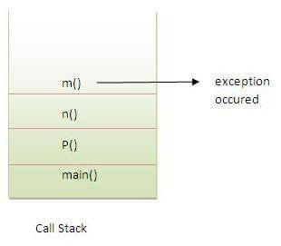

In the above example exception occurs in m() method where it is not handled,so it is propagated to previous n() method where it is not handled, again it is propagated to p() method where exception is handled.

Exception can be handled in any method in call stack either in main() method,p() method,n() method or m() method.

Rule: By default, Checked Exceptions are not forwarded in calling chain (propagated).

***Program which describes that checked exceptions are not propagated***

1. **class** TestExceptionPropagation2{
2. **void** m(){
3. **throw** **new** java.io.IOException("device error");//checked exception
4. }
5. **void** n(){
6. m();
7. }
8. **void** p(){
9. **try**{
10. n();
11. }**catch**(Exception e){System.out.println("exception handeled");}
12. }
13. **public** **static** **void** main(String args[]){
14. TestExceptionPropagation2 obj=**new** TestExceptionPropagation2();
15. obj.p();
16. System.out.println("normal flow");
17. }
18. }

**[Test it Now](http://www.javatpoint.com/opr/test.jsp?filename=TestExceptionPropagation2" \t "_blank)**

Output:Compile Time Error